**MATERIALS: PROCEDURES AND DOCUMENTATIONS**

**Material handling procedure and related documentations:**

Materials are the basic components of manufacturing and production process in a goods manufacturing entity. Materials are also called raw materials which are used in the production of a finished products (such as Crude Oil is a raw material for Petrol, Milk is a raw material for Yogurt, Yarn is a raw material for Garment whereas Petrol, Yogurt and Garment are the finished products).

In some manufacturing processes, raw material cost is major part of its total production cost and any loss of control over material may cause significant increase in production cost. It is, therefore, important for any entity to control the material activities from purchase till its use.

An entity that purchases materials to be used in its production or further sale, must ensure that proper procedures are in place to enable the controls over their costs, purchase quantity, quality as well as usage quantity.

In order to make the controls effective, their documentation is necessary so that verifiable records can be maintained.

**Example 01:**

A Limited is engaged in the manufacturing of Cotton Garment. It uses yarn as its raw material. It requires 10 tons of yarn for the next production.

1. The Production Department raises the Material Requisition (M.R) to the Store / Warehouse of the company depicting the quantity and time at which the stock is needed.

*(Materials can only be issued against a materials/stores requisition. This document must record not only the quantity of goods issued but also the cost centre or the job number for which the requisition is being made. The materials requisition note may also have a column, to be filled in by the cost department, for recording the cost or value of the materials issued to the cost centre or job.)*

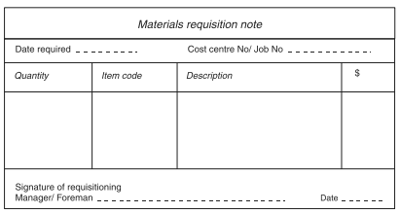

1. The Store / Warehouse of the company raises a Purchase Requisition (P.R) to the Purchase / Procurement Department.

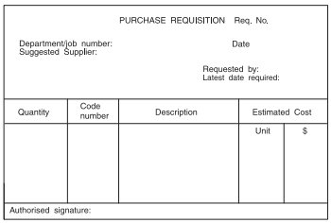

1. The Purchase / Procurement Department raises a request for quotation to the yarn suppliers and on the basis of accepted quotation, raises a Purchase Order (P.O) which is delivered to the supplier.

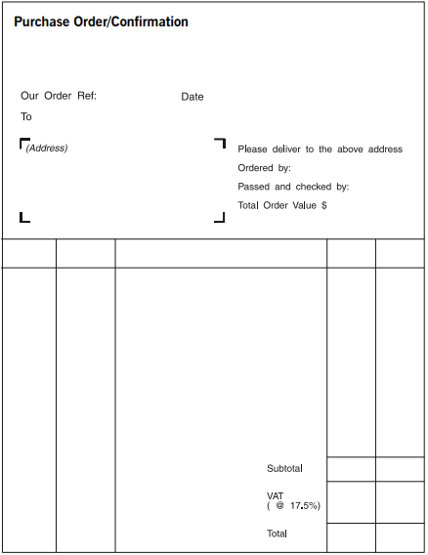

1. The supplier on the basis of P.O (which includes quantity, rate and time of delivery) delivers the yarn at the store / warehouse of A Limited and issues a Goods Dispatch / Delivery Note (GDN) to the Store and Purchase/ Procurement Departments of “A Limited”.

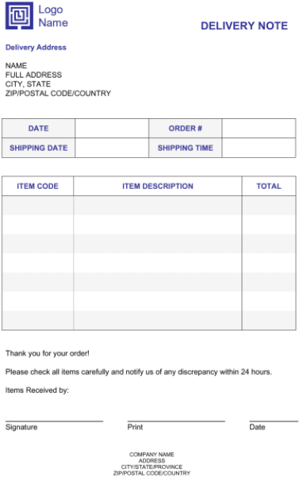

1. The storekeeper / warehouse in-charge of “A Limited” issues a Goods Received Note (GRN) the copy of which is given to the supplier and Purchase / Procurement Department after inspecting the goods along with the invoice.

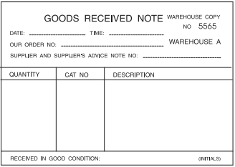

Documentation of purchase process is therefore needed:

* to ensure that the procedures for ordering, receiving and paying for materials has been conducted properly, and there is no error or fraud
* to provide a record of materials purchases for the financial accounts
* to provide a record of materials costs for the cost and management accounts.
* to ensure physical controls over the materials and to ensure its proper usage
* to ensure that each document is authorized by line manager

The detailed procedures for purchasing materials and the documents used might differ according to the size, complexity and nature of the business. However, the basic requirements are same for all types of business where material purchases are made.

**INVENTORIES AND ITS VALUATION**

**Types of inventories:**

In manufacturing entities, inventory comprises raw materials, work-in-process, stores, spares and tools and finished goods.

**Raw materials** are purchased by manufacturing entities for consumption in the production during a period. They are treated as expense when these are issued to production whereas those raw materials that still exist, at the end of the reporting period are treated as current assets and are termed as inventories.

**Cost:** Purchase price including import duties & taxes (other than those subsequently recoverable by the entity), transport, handling and other cost directly attributable to the purchase of goods. Trade discounts, rebates and other similar items are deducted in determining the cost. (IAS 2)

**Work-in-process** is the inventory on which partial costs have been incurred till period end but it is not yet finished or completed and further cost is required to complete it. For instance, for manufacturing a liter of mango juice, 100% of mango pulp (raw material) has been put into process whereas the labour has worked only 50% up to the end of the reporting period. Due to this, the product is neither considered completed nor it is raw material any more. This kind of inventory is called work-in-process and is treated as current asset.

**Cost**: Cost of raw material as determined above, plus direct labour cost and production overhead costs to the extent of work done.

**Finished goods** are the final products which have been completed and stored in a warehouse known as “Finished Goods Store”. The goods that have been sold to the customers are treated as cost of sales in the financial statements whereas, the goods that have not been sold till the end of the reporting period are considered as inventories.

**Cost**: Cost of raw material as determined above, plus direct labour cost and production overheads.

**Stores, spares and loose tools** are used in the equipment and machinery and are kept in inventory so that in case of any damage to the machinery or equipment, the production should not stop and necessary tools are available in stock to resume the production at earliest. The unused stores, spares and loose tools at period end is treated as inventory while used stores, spares and loose tools is charged as expense in financial statements.

**Cost:** Same as Raw Material

**Valuation of Inventory:**

An entity is required to evaluate, at the end of each reporting period, the net realizable value of its inventories and value the inventories at lower of:

* Cost or
* Net realizable value

The cost of the inventories is ordinarily lower than the net realizable value. Therefore, the inventories are carried at their costs. However, the cost may exceed the net realizable value in the following cases:

* The inventories are damaged,
* The inventories have become wholly or partially obsolete,
* The selling price of the inventories have declined, or
* The estimated cost of completion or estimated cost to be incurred to make the sale have increased (IAS 2).

The historical cost of inventory is usually measured by one of the following methods:

* First in, first out (FIFO)
* Weighted average cost (AVCO)

The FIFO and weighted average cost (AVCO) methods of inventory valuation are used within perpetual inventory systems. They can also be used to establish a cost for closing inventory with the period-end inventory system.

**First-in, first-out method of valuation (FIFO)**

With the first-in, first-out method of inventory valuation, cost of inventory consumed is strictly based in the order of purchase means first purchase is issued first and so on. In simple words, the first items that are received into inventory are the first items that go out.

To establish the cost of inventory using FIFO, it is necessary to keep a record of:

* the date that units of inventory are received into inventory, the number of units received and their purchase price (or manufacturing cost)
* the date that units are issued from inventory and the number of units issued.

With this information, it is possible to put a cost to the inventory that is issued (sold or used) and to identify the cost of the items still remaining in inventory.

Since it is assumed that the first items received into inventory are the first units that are used, it follows that the value of inventory at any time should be the cost of the most recently-acquired units of inventory.

Example:

On 1 January a company had an opening inventory of 100 units which cost Rs.50 each.

During the year it made the following purchases:

* 5 April: 300 units at Rs. 60 each
* 14 July: 500 units at Rs. 70 each
* 22 October: 200 units at Rs. 80 each.

During the period it sold 800 units as follows:

* 9 May: 200 units
* 25 July: 200 units
* 23 November: 200 units
* 12 December: 200 units

Solution:

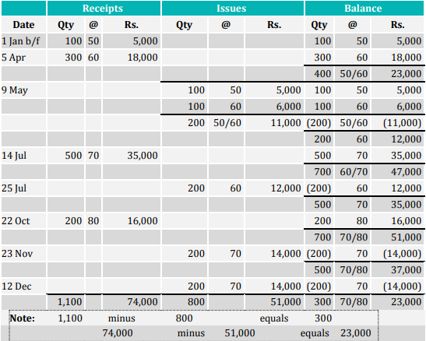

**Weighted average cost (AVCO) method**

With the weighted average cost (AVCO) method of inventory valuation it is assumed that all units are issued at the current weighted average cost per unit.

The normal method of measuring average cost is the perpetual basis method. With the perpetual basis AVCO method, a new average cost is calculated whenever more items are purchased and received into store. It is also termed as running weighted average method, as at new purchase with different price will change the average cost of inventory. The weighted average cost is calculated by using the following formula:



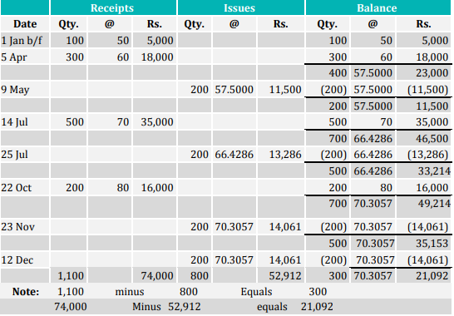

**Journal Entries:**

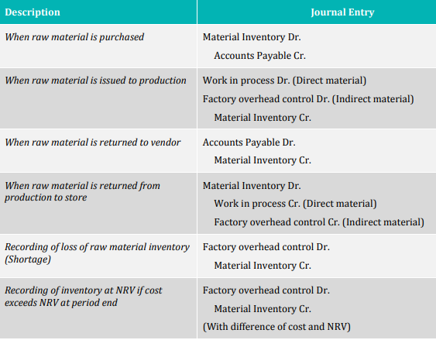

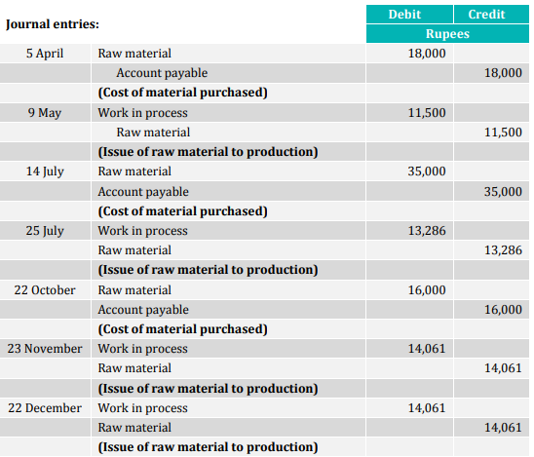

**Practice Questions:**

**Question. 01**

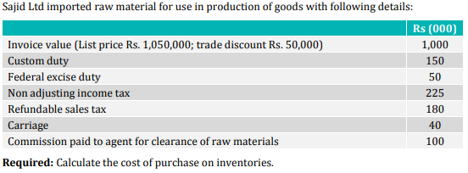

Answer is Rs. 1,565.

**Question. 02**

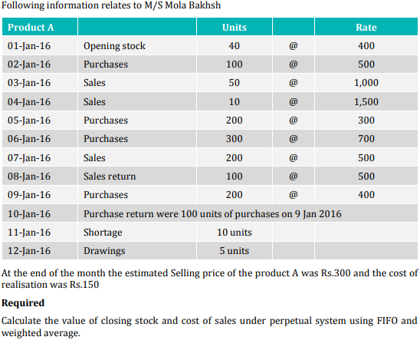

**Solution:**

